Table of Contents

1. Introduction 3
2. Literature Review 3
3. Objectives 3
4. Comparison With Related Works and Research Gap Analysis: 4
5. Problem Statement 5
6. Project Structure 5
7. Visual Diagram 7
7.1 System Architecture 7
7.2 Circuit/PIN Diagram 8
7.3 Database Structure (Schema + ER Diagram) 8
7.4. Flow Chart 9
8. Gantt Chart 10
9. Cost Analysis and Comparison of Components 10
10. Results/Advantages of the System 11
11. Limitations 12
12. Future Work 12
13. Conclusion 12
14. References 12

1. Introduction
In the home, in the office and in restricted areas, security is a must. Traditional security involves CCTV cameras and alarm systems that must be constantly monitored by human beings and cannot automatically identify the possible security threats.

With the progress of Artificial Intelligence (AI), Computer Vision and Internet of Things (IoT), it is now possible to create intelligent security systems capable of real-time object and person detection and recognition. These technologies are able to improve security by reducing the need for human interaction and decision making.

The objective of this project is to create a smart security system and monitoring system based on an object detection model called YOLO (You Only Look Once) and Raspberry Pi. The system gathers live video via the camera and locally analyzes the video to identify and track authorized and unauthorized individuals. For the user, the notifications are sent based on the result of the detection, in real time, so that the user acquires a first-hand awareness of security events.

Edge computing enables data analysis to be performed directly on the Raspberry Pi, reducing response times, improving data privacy and reducing cloud reliance.

2. Literature Review
The IoT based surveillance systems are attracting a lot of attention for providing remote and intelligent surveillance. Raspberry Pi's low cost, compactness, embedded system capabilities are one of the reasons why it's used in such systems. The majority of the security systems only provide motion detection – and that can lead to false alarms and it cannot tell who is responsible for the event. In recent years, with the development of computer vision and deep learning technologies, the accuracy of object detection has been enhanced, such as by using the YOLO model that is capable of real-time detection and classification of objects. Further, edge computing is gaining popularity in the application implementations that are related to security. Edge-based systems provide reduced latency, enhanced privacy, and quicker decision-making due to the processing of data on the edge instead of on remote servers. The entire system is a hybrid system, using YOLO detection and combining edge computing, which is an effective and intelligent security solution.

3. Objectives
This project aims to:
- To develop a smart Security System based on an Object Detection Model called “YOLO”. As time goes on, accurate real-time identification and classification of authorized and unauthorized individuals.
- To notify instantly of any security events.
- To build a simple and efficient solution using Raspberry Pi.
- To take advantage of edge computing to get quicker local computations.
- To increase the security and convenience of users, automation and convenience are improved.

4. Comparison With Related Works and Research Gap Analysis:
Table 1: Comparison with related works

Features | Unified, Real- Time Object Detection (2016) | Optimal Speed and Accuracy of Object Detection (2020) | Face Detection Model with Convolution and 3D Feature (2024) | Surveillance System Using Face Recognition Raspberry Pi  (2026)
Controller | Raspberry Pi 3 | Microcontroller | Raspberry Pi 4 | Raspberry Pi 5
Vision System | Camera + OpenCV | USB Camera | Camera +  Computer Vision | IP Camera + OpenCV
Detection Method | YOLOv4 | YOLOv4 | Computer Vision with VGG16 | LBPH
Object Tracking | No | Limited | Yes | Real-Time  Position Tracking
Camera-Based Picking | Limited | Limited | Yes | Yes
OpenCV Integration | Yes | No | Yes | Yes
Detection Capability | 20+ object classes (PASCAL VOC) | 24+ object classes | 25+ object classes | 47+ object classes
Speed Performance | Low | Moderate | High | High
Accuracy | 57.9% mAP | 63.4% mAP, | 67.5% mAP | 72.3% mAP
Cost Efficacy | Low | Medium | High | Very High

Research Gap Analysis

Table 2: Research Gap Analysis

Limitation of Existing Systems | Digital Access Solution
Dependence on Raspberry Pi Model | Uses computer vision only
Works on object detection only | Image classification
Image recognition | Authorized unauthorized detection
No mobile application notification system | Have mobile Application Notification system
IP camera integration | Supports phone-based IP webcam
Limited scalability | Easily expandable to more objects
Basic automation | Complete vision-guided autonomous operation
Minimal software modularity | Modular Python architecture

5. Problem Statement
Current conventional security systems rely on motion detection and/or surveillance without being able to analyze the identity of a detected person, thereby causing unauthorized access to occur unnoticed.
What is required is an intelligent security system that can detect, classify and notify users about any security threats. Such an approach will not only ensure security but save effort and enable real-time monitoring as well. The suggested Digital Access Security System integrates YOLO detection, person recognition, edge computing via Raspberry Pi, and Android notification system. It does not merely detect people, but classifies and recognizes authorized and unauthorized persons while generating real-time alerts for users.

6. Project Structure
The Digital Access Security System utilizes a three-tier structure, consisting of the Input Layer, Processing Layer, and Output Layer. The system uses a real-time person detection and recognition system that uses YOLO computer vision system on the Raspberry Pi.

6.1 Input Layer
The Input Layer gathers information regarding the environment. The camera connected to the Raspberry Pi collects visual inputs from the surrounding environment continuously. The frames are used by the system for detection and recognition purposes.

Components:
- Camera Module
- Real-Time Video Stream
- Image Acquisition Unit

6.2 Processing Layer
The Processing Layer serves as the heart of the system. The Raspberry Pi acquires images from the camera and then processes them using the trained YOLO (You Only Look Once) algorithm. After processing, the algorithm identifies both authorized and unauthorized persons.

If the person is authorized, access will be automatically granted; if not, the system will send an alert message to the mobile application immediately. All processing happens locally at the Raspberry Pi through edge computing technology.

Components:
- Raspberry Pi
- YOLO Object Detection Algorithm
- Image Preprocessing Unit
- Person Identification Unit
- Decision-making Unit

6.3 Output Layer
The Output Layer relays information about the detected persons to the user interface. When an authorized person is detected, he can have automatic access. However, in case of an unauthorized person, the system sends a notification alert to the mobile application right away.

Components:
- Android Application
- Notification Service
- Alert System
- Access Control Interface

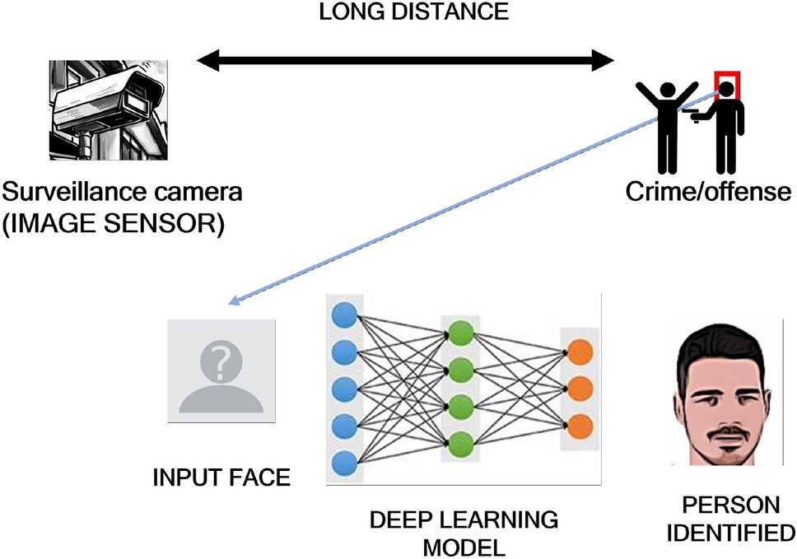

Fig 1: Project Structure

7. Visual Diagram

7.1 System Architecture
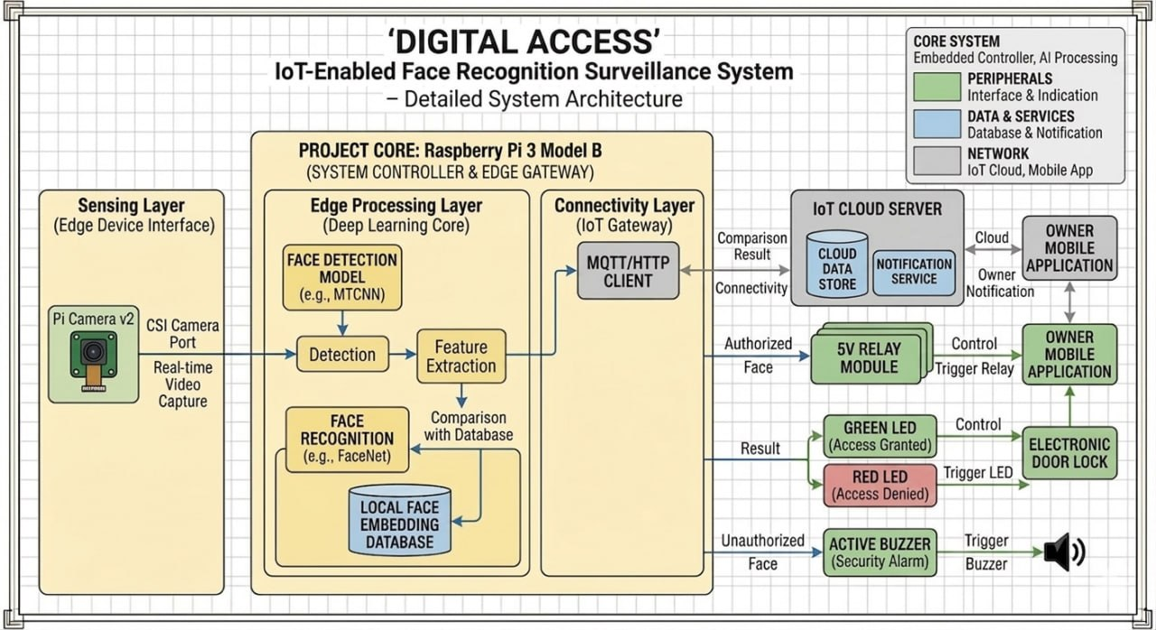

Fig 2: System Architecture

7.2 Circuit/PIN Diagram
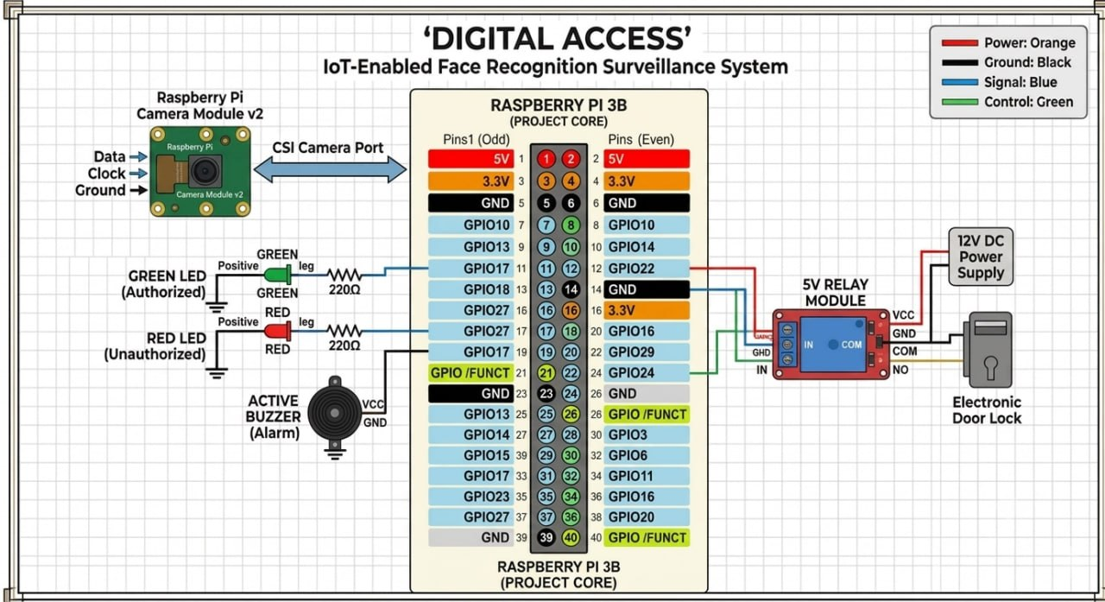

Fig 3: Circuit/PIN Diagram

7.3 Database Structure (Schema + ER Diagram)

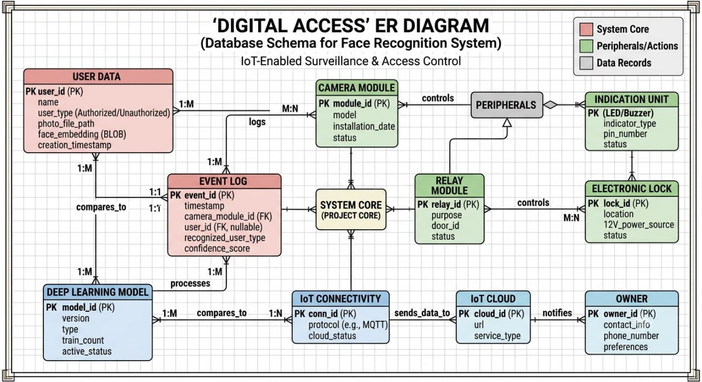

Fig 3: Schema + ER Diagram

7.4. Flow Chart

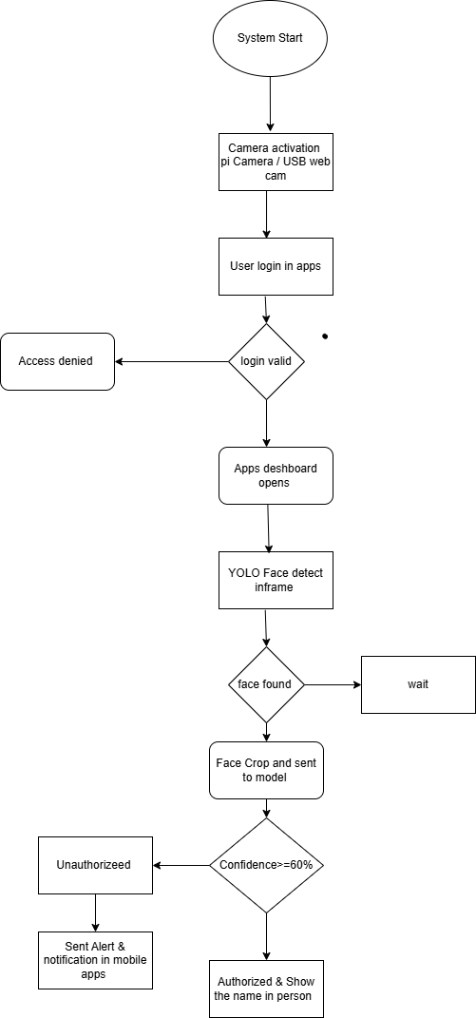

Fig 4: Flow Chart

8. Gantt Chart
Table 3: Gantt Chart

Task / Activity | W1 | W2 | W3 | W4 | W5 | W6 | W7 | W8 | W9 | W10 | W11 | W12
Requirement Analysis | ☑ | ☑ | ☐ | ☐ | ☐ | ☐ | ☐ | ☐ | ☐ | ☐ | ☐ | ☐
Raspberry Pi Setup | ☐ | ☑ | ☑ | ☐ | ☐ | ☐ | ☐ | ☐ | ☐ | ☐ | ☐ | ☐
Camera Integration | ☐ | ☐ | ☑ | ☑ | ☐ | ☐ | ☐ | ☐ | ☐ | ☐ | ☐ | ☐
Dataset Collection & Preprocessing | ☐ | ☐ | ☐ | ☑ | ☑ | ☐ | ☐ | ☐ | ☐ | ☐ | ☐ | ☐
Face Detection & Model Training | ☐ | ☐ | ☐ | ☐ | ☑ | ☑ | ☑ | ☐ | ☐ | ☐ | ☐ | ☐
Mobile App Development | ☐ | ☐ | ☐ | ☐ | ☐ | ☑ | ☑ | ☐ | ☐ | ☐ | ☐ | ☐
Notification System | ☐ | ☐ | ☐ | ☐ | ☐ | ☐ | ☐ | ☑ | ☑ | ☐ | ☐ | ☐
System Integration | ☐ | ☐ | ☐ | ☐ | ☐ | ☐ | ☐ | ☑ | ☑ | ☑ | ☐ | ☐
Testing & Optimization | ☐ | ☐ | ☐ | ☐ | ☐ | ☐ | ☐ | ☐ | ☐ | ☑ | ☑ | ☐
Final Presentation | ☐ | ☐ | ☐ | ☐ | ☐ | ☐ | ☐ | ☐ | ☐ | ☐ | ☐ | ☑

9. Cost Analysis and Comparison of Components
Table 4: Cost Analysis

Category | Component Name | Unit Price (BDT) | Quantity | Total (BDT)
Processing | Raspberry Pi 3 (1GB) | 10500 | 1 | 10500
Processing | MicroSD Card (32GB) | 15,00 | 1 | 15,00
Vision | Camera Module (Pi Cam-  era/USB) + IP Camera | 18000 | 2 | 18000
Source | Power Bank | 2500 | 1 | 2500
Voltage | Voltmeter | 700 | 1 | 700
Device | Glue gun | 600 | 1 | 600
Power | Power Adapter (5V 3A) | 700 | 1 | 700
Misc. | Jumper Wires | 300 | 1 | 300
Misc. | Breadboard | 150 | 1 | 150
Misc. | Casing / Box | 900 | 1 | 900
Misc. | HDMI USB | 700 | 1 | 700
Misc. | HDMI cable | 400 | 1 | 400
Misc. | Cooling Fan | 600 | 1 | 600
Misc. | Extra Cost | 600 | 1 | 600
Total Cost |  |  |  | 38150 BDT

Table 5: Cost Comparison.

10. Results/Advantages of the System
- The system provides real-time detection and tracking of persons.
- The system removes the need for constant observation.
- Alerts are sent instantly via the Android app.
- Security is improved by applying YOLO-based AI.
- The system is cost-effective as implemented on the Raspberry Pi.
- Local processing speeds up alerts and ensures privacy of the users.

11. Limitations
- Detection accuracy decreases in low lighting conditions.
- Object detection accuracy relies on the quality of the training data.
- Computational capacity of the system is limited due to Raspberry Pi.
- Lighting conditions influence detection accuracy.

12. Future Work
- Creation of the capability of working in dark places.
- Data storage on the cloud will serve as a backup solution.
- Integration with the smart door lock system.
- Removal of limits of simultaneous people detection.

13. Conclusion
Digital Access Security System is a highly advanced smart security solution that uses Raspberry Pi and YOLO-based object detector. The system provides instant notifications, improves security, and reduces the need for manual supervision. Its low cost, efficiency, and scalability make it suitable for modern smart security applications. This system can improve security efficiency significantly.

14. References

- Redmon, J., Divvala, S., Girshick, R., & Farhadi, A. "You Only Look Once: Unified,Real-Time Object Detection." https://arxiv.org/abs/1506.02640 .
- Bochkovskiy, A., Wang, C. Y., & Liao, H. Y. M. "YOLOv4: Optimal Speed and Accuracy of Object Detection." 2020. https://arxiv.org/abs/2004.10934
- EFD-YOLO: An Enhanced Face Detection Model with Deformable Convolution and 3D Feature Fusion https://ieeexplore.ieee.org/document/11382421/
- Smart Tourist Surveillance System Using Face Recognition and Raspberry Pi https://ieeexplore.ieee.org/document/11436536

